**Project 7: How to download and run project from GIT hub**

**Create github repository as simple-reactjs-app**

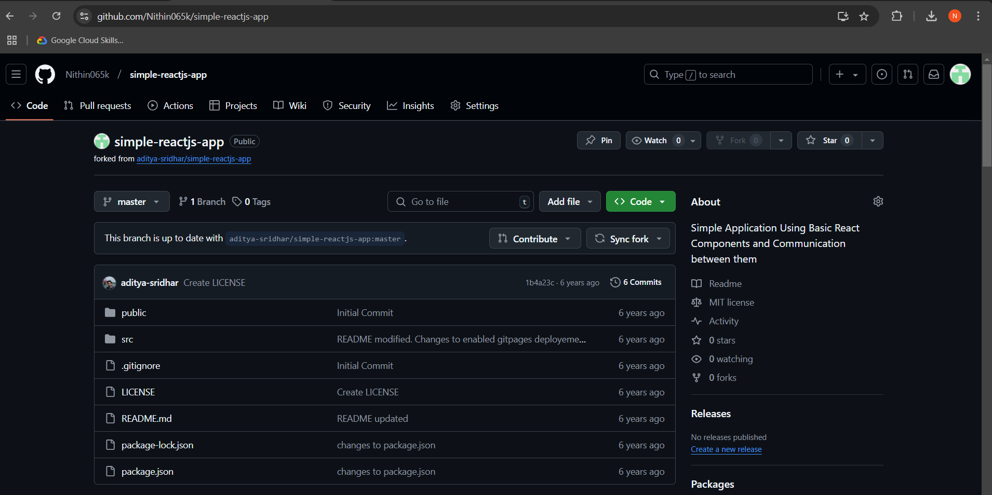

**Git bash to install and start reactjs**

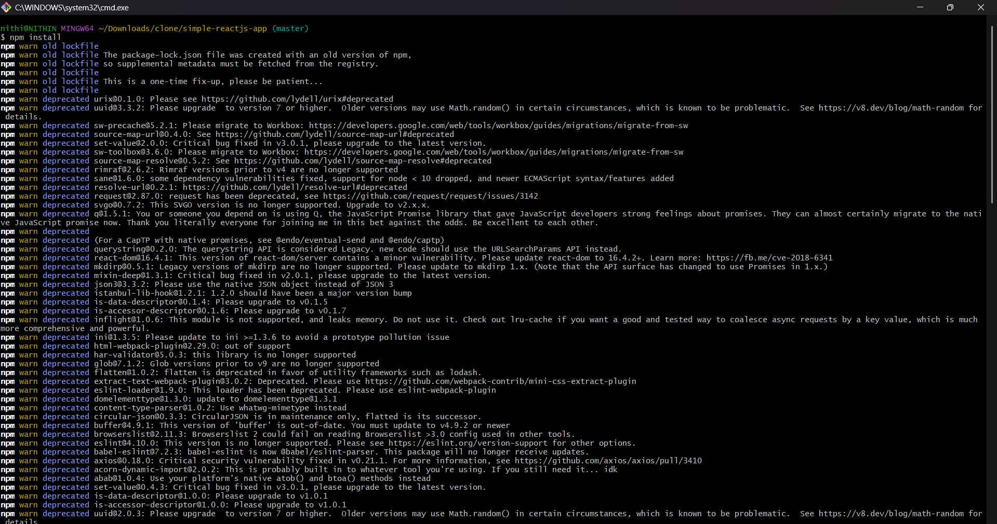

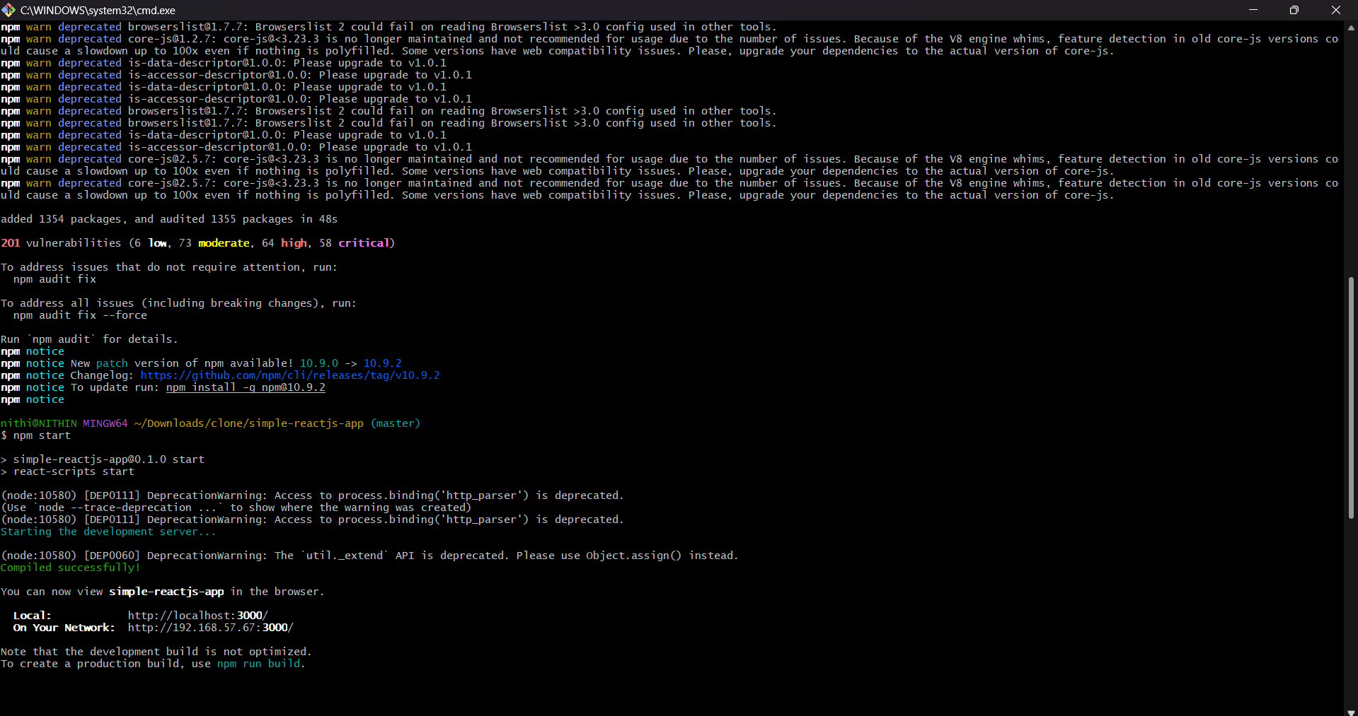

**Final output**

